PART 3

***Tả tranh và trả lời 2 câu hỏi liên quan.***

**1. Tranh 1 người nhìn máy bay + 1 người đứng đợi tàu**

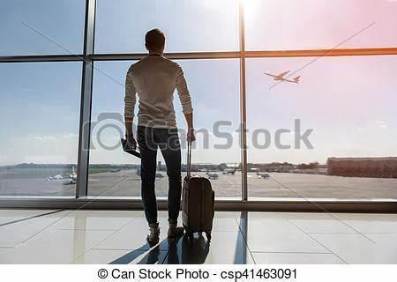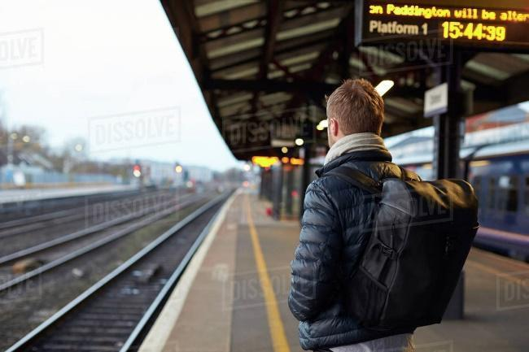

* Describe 2 pictures

Both of the pictures depict the means of transport.

In the first picture, I can see that there is a man sitting next to his luggage suitcase. He's wearing a very polite suit, I guess he's a businessman or something like that. To be more specific, he was standing at the airport and watching the plane go up in the sky.

In the second picture, there is a man wearing a denim jacket and a red backpack. He is waiting for the train to arrive. I guess he's about to take the train to his hometown to visit his parents. Looking at the background I can tell that it’s a nice weather

* Why do people prefer to go by plane than by train?

From my perspective, each mean of transport has its own advantages, airplanes are not an exception. When compared to the train, the plane is considered to be a faster and more convenient means of travel. Wherever you want to go or need to go suddenly, especially abroad, the plane is a perfect choice as it will take you to the place you want in the fastest and simplest way. Besides, flying is one of the safest ways to travel, you can stay safe in the knowledge that your plane has been checked, double checked, and checked once more before you even step on board.

* Why does flying make many people feel uncomfortable?

Some people have gradually become uncomfortable flying, such as me. I know some people think flying is one of the most exciting and magical things, but I personally am not a fan. FMP, maybe there are 4 main reasons that make many people feel uncomfortable when they’re flying. These are: remembering a bad flight, hearing scary stories about flying, taking a flight while feeling nervous, or traveling during a personally stressful phase in their life. Besides, it's extremely bad if your flight is delayed, which happens quite often in the airline industry.

**2. Tranh 2 bố con cho ngựa ăn + trẻ con chơi với rắn**

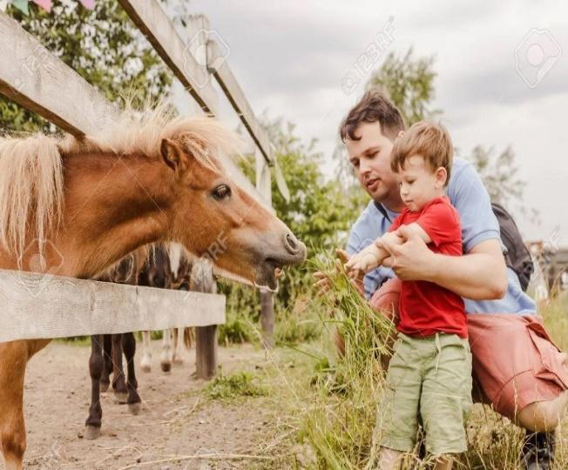

* Describe:

|  |  |
| --- | --- |
| **1** | **Both of the photos depict the children's contact with animals.** |
| 2 | In the first picture, I can see the father and his son playing with a horse. The father wears a ... shirt and the son wears a .. shirt. The boy seems very happy because maybe it's the first time he saw a horse. looking at the background of the photo, I guess this place is the park and they are enjoying their day off to hang out. |
| 3 | Looking in the second picture, I can tell that this is a teacher with her students. The teacher wears a ...shirt and she is guiding the kids to learn and play with the snake on the table. The kids look excited and happy. |

* Do you like interacting with animals?

I don't interact with animals myself, but I know that many people enjoy spending time with them! Animals offer companionship, comfort, and can even be therapeutic. Whether it’s playing with a dog, watching birds, or observing wildlife, interacting with animals can help reduce stress and create positive emotions. Animals often show affection and loyalty, which can make people feel valued and loved. I think the bond between humans and animals is special, and it’s wonderful to see how much joy animals bring to people’s lives.

* Should children be exposed to animals?

From my perspective, I see eye to eye with the exposure of children to animals from a young age. Having a pet has various benefits for children. According to a survey, children who developed the closest attachments or strong bonds to their pets didn't have the rates of anxiety and depression. Furthermore, caring for their furry friends, such as taking them for a walk, feeding them and grooming them teaches the children to be responsible not only towards other animals but also with people.

**3. Đề xe đạp + chèo thuyền**

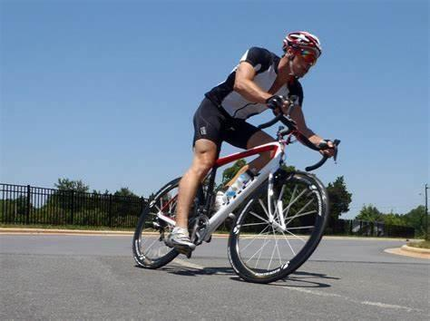 

* Describe:

Looking at the 2 pictures, there are 2 types of sports including individual sports and team sports. As I can see, the first picture shows a rowing team. It looks like they are facing a strong wave from the river because the athletes are pulling as hard as they can. They are wearing **life jackets** and the competition seems dangerous. On the other hand, in the second picture, I can see a male athlete in a bike **jersey** and helmet. It looks like he is taking part in a competitive **road cycling** which is held on paved roads with a lot of trees around.

* What are the difficulties of these 2 sports?

Each sport has its own challenge. As for racing bikes, the first difficulty is that it has a risk of injury. Besides, racing bikes is a sport that requires **keeping the pace** and understanding how to handle unexpected situations. Regarding the rowing race, I think the hardest part is the co-operation and the ability to tolerate bad weather conditions. Therefore, it is not only physically demanding but mentally exhausting as well.

* Why do some people prefer team sports to individual sports?

From my perspective, people who choose to play team sports often receive support from their team members, so it suits best for people who are outgoing, extroverted and sociable. They find themselves most enjoyable while interacting and cooperating with others to achieve the goal. Moreover, team sports teach their players valuable life lessons that they could not learn from individual sports. For example, team sports teach people about leadership which is one of the most important skills nowadays.

4. Tranh 1 người đàn ông đi du lịch đang lấy máy ảnh chụp núi. Anh ta đeo balo du lịch. Phía trước là thung lũng và đồng cỏ hoang sơ + 1 cặp đôi kéo vali trên đường. Phía trước là tòa nhà cổ kính cao trong thành phố.

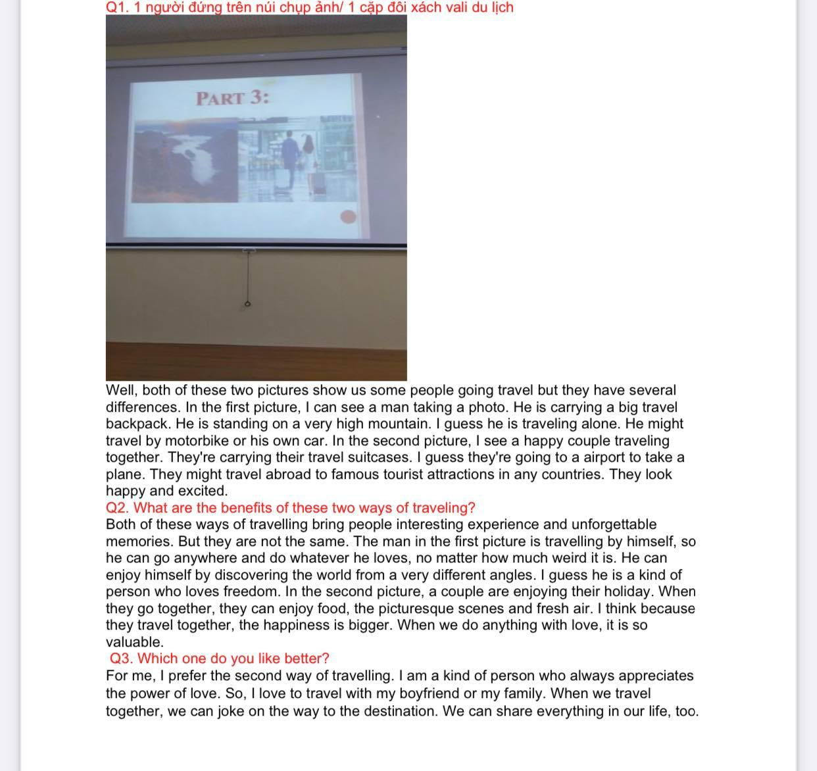

* Describe: Both of the photos depict two different ways of traveling. In the first picture, I can see a man wearing …T-shirts, … pants, and a backpack. In front of him are valleys and wild grasslands. I guess he is traveling alone and his journey is wild travel. Meanwhile, in the second picture, there is a young couple walking on the street. The man wears…., while the woman wears….. They are holding suitcases. I guess they are traveling in a city because I can see an ancient building. Maybe they are spending time relaxing on their days off.
* What are the benefits of these 2 ways of traveling?

I think people choose these types of traveling according to their hobbies,

demands and situations. Young people who are passionate about exploring

nature and enjoying themselves would prefer to travel alone. Because they will have more time to focus on their own experience rather than on others. On the

contrary, someone who wants to have the opportunity to have fun and create memories with family or friends will choose to travel in groups.

* Which one do you like better?

For me, I prefer traveling in groups to going alone for some reasons. First of all, I am not good at determining directions and reading maps, so I get lost frequently. Therefore, I need fellow travelers to help me stay on the right track in the journeys. Moreover, I also love the lively and entertaining atmosphere when there are a lot of people participating. On holiday, I normally have trips with family or a team of friends. We spend time enjoying the moments and making memories.

**5. Gia đình mua sắm trong siêu thị + người phụ nữ bán dâu tây ở chợ**

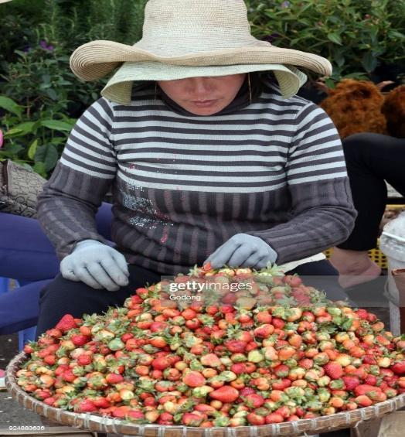

* Describe: Both of the 2 pictures depict the ways of shopping nowadays. In the first picture, I can see a family buying some food at the supermarket. There is a father, a mother and their child. They seem to be very happy and comfortable. I guess they are used to shopping at the supermarket. Meanwhile, in the second picture, there is a woman who is selling strawberries. She is wearing ... Looking at the background I can guess that this is a normal market.
* Benefits of markets and supermarkets?

From my perspective, both ways of shopping have their advantages. First of all, when you buy food at the market, you can save money because the food at the market is usually cheaper than at the supermarket. Besides, you'll have access to food with fewer, if not, chemical-free foods. About the supermarket, it can maintain a large variety of all the goods and thus, help customers in the selection of best goods. Moreover, at the supermarkets, customers can feel freer, more comfortable because they choose and carry products themselves.

* Why do many people not like shopping?

I think there are several reasons that some people hate shopping. Firstly, shopping takes time, some people think it's not worth spending their precious time shopping. Secondly, the fact that shopping encourages us to buy things that we do not need or use cannot be denied. This can lead to debts. And finally, people tend to invest more money in experiences than shopping. That is my opinion about this situation.

**6. Tranh du lịch thành phố + du lịch vùng núi**

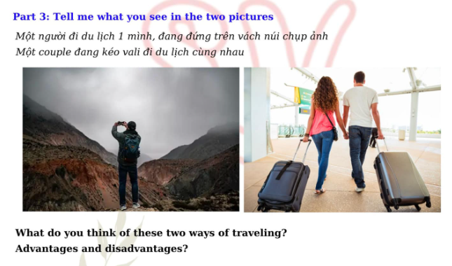

* Describe

The first picture shows a bustling city with modern skyscrapers, busy streets, and people walking or driving. There are iconic landmarks, perhaps a famous monument, a park, or a shopping district. The scene feels energetic, with lights, stores, and crowds, capturing the fast-paced vibe of urban life. The second picture depicts a serene mountain landscape. There are rolling green hills, rocky peaks, and clear blue skies. A few hikers can be seen enjoying the tranquility, surrounded by nature’s beauty. The mountains are vast and peaceful, offering a sharp contrast to the busy city scene. It’s calm, fresh, and full of natural wonders.

* What do you think of these two ways of travelling?

Both city and mountain travel offer unique experiences. City travel is vibrant and full of life, perfect for those who love culture, shopping, and exploring new urban environments. On the other hand, mountain travel offers a peaceful escape, ideal for nature lovers, hikers, and those seeking solitude and adventure in the great outdoors. It all depends on whether you want to immerse yourself in a fast-paced, cultural environment or relax and recharge amidst nature.

* Advantages and disadvantages of these 2 ways of travelling?

City travel offers the convenience of modern amenities, abundant attractions, and the chance to explore diverse cultures. You can visit museums, dine in famous restaurants, and enjoy vibrant nightlife. However, it can be crowded, noisy, and expensive, especially in tourist hotspots. Mountain travel, on the other hand, offers breathtaking views, fresh air, and peaceful surroundings, perfect for outdoor activities like hiking and camping. The downside is that it can be remote, with fewer amenities and services, and physical exertion may be required for some activities. Each has its pros and cons, depending on what type of experience you’re looking for.

**7. Tranh nhiều người trên xe bus + 1 người mở cửa vào ô tô**

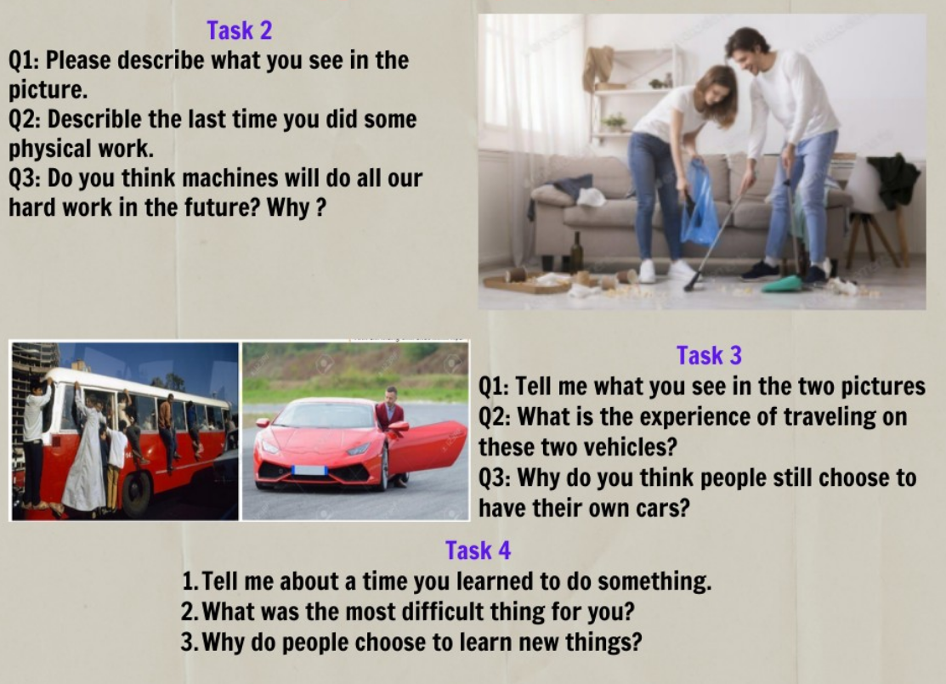

* In the first picture, I see a lot of people standing around an old white Bus, underneath there are puddles and a man is standing on top of the bus to take things off. I guess all of them have just finished a long journey and are waiting to get their things down to return home.

Compared to the first picture, the second picture depicts a man in a white shirt and blue jeans. He is opening the door of a red car to get into the car. I think he is about to move somewhere else, maybe work. Through the two pictures, I think the people in the first picture have a poorer life than the man in the second picture.

* I think these types of vehicles are suitable for each person's demand and financial situation.

People who have a limited budget and have to travel frequently will prefer public transportation such as bus, coach and train. It costs them a cheap fee and is quite convenient. But sometimes, it is crowded and noisy, which makes people feel uncomfortable. On the contrary, personal vehicles like cars can provide users with comfort, privacy and safety. Furthermore, they can have control over their time to travel.

* Many people choose to have their own car because with your own car, you'll enjoy the convenience of being able to travel anywhere you want, any time you want. Part of owning your car is enjoying the convenience but also experiencing your own freedom. And you can also save time in the long run. When you don't have to spend time waiting for a bus, a train, or ride-share system, you can leave work or your home whenever you want.

**8. Ăn ở nhà + ăn nhà hàng**

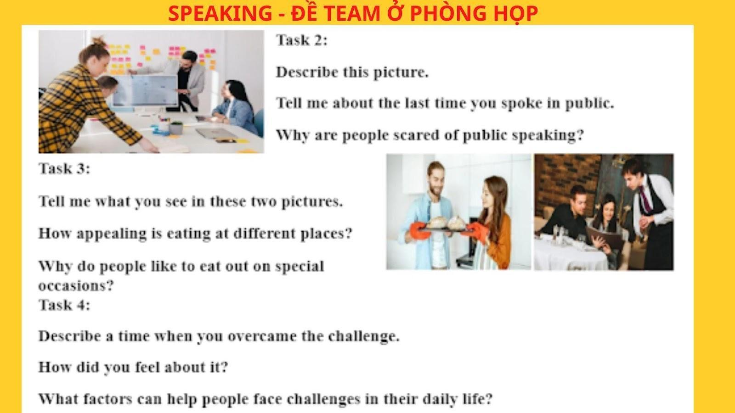

* Looking at the 2 pictures, there are couples who are about to eat their meal but in 2 different places. In the first picture, there seems to be a couple cooking a meal with each other. They are holding a tray with freshly baked bread on it. Meanwhile, the second picture shows another couple making an order in a restaurant. They are looking carefully at the menu to look for their desired dishes. The restaurant is very luxurious I think.
* Eating at different places is very appealing. We can enjoy eating many different scrumptious and mouth-watering foods in different ways of cooking. Moreover, we can also enjoy the great services instead of having to cook in the kitchen and wash the dishes on our own. Furthermore, eating at different places is very convenient for me and it helps me let my hair down after a hard working day while enjoying a delicious meal.

**9. Tranh 1 người viết thư + 1 cô đánh máy email**

* Tả 2 tranh

In the first picture, a person is sitting at a desk, focused on writing a letter by hand. The desk is likely filled with paper, a pen, and an envelope, creating a calm and traditional atmosphere. The person appears to be carefully writing, taking their time with each word. In the second picture, a woman is seated in front of a computer, typing an email. The screen is likely displaying a draft of her message, and she seems to be typing quickly, possibly multitasking in a modern, digital environment.

* Do You Prefer Handwriting or Typing?

Personally, I don't have preferences, but many people enjoy handwriting because it feels more personal and thoughtful. It can be a meaningful gesture, especially for special occasions like writing a letter to a friend or loved one. On the other hand, typing is faster and more convenient, especially for everyday communication, allowing people to send messages instantly. Both methods have their charm depending on the context and the intent behind the message.

* Which One is More Convenient?

Typing is generally more convenient because it’s faster, especially when sending messages over email or online. It allows people to quickly revise and send information, making it ideal for work or daily communication. Handwriting, while more personal and meaningful, takes more time and effort, especially for longer letters. However, for moments that require extra care or a personal touch, handwriting might still be the preferred choice.

**10. Tranh gia đình đang cổ vũ bóng đá ở sân vận động + tranh nhóm người xem hòa nhạc**

* Tả 2 tranh

In the first picture, a family is sitting together in a stadium, cheering for their favorite football team. The atmosphere is full of energy as the crowd around them is also excited, waving flags and shouting in support. The family members seem to be enjoying the game, wearing team jerseys and sharing the thrill of the match. In the second picture, a group of people is attending a concert, likely enjoying live music. The crowd is focused on the performers, with some people swaying to the rhythm, while others are taking pictures. The lighting and stage setup create a lively and engaging environment.

* Which Activity Do You Prefer?

Personally, I don't have preferences, but both activities offer unique experiences. Football games provide excitement, a sense of community, and the thrill of competition, while concerts offer a more personal connection to music and the energy of live performances. The choice depends on whether you enjoy the adrenaline of a sports event or the connection of enjoying music in a crowd.

* Which Activity Attracts Young People More?

Both activities are popular among young people, but concerts might have a slight edge in recent years, especially with the rise of music festivals and live performances by famous artists. Young people often enjoy the lively atmosphere, social aspect, and the chance to connect with others who share the same music interests. However, football matches also attract a huge young audience, especially in countries where sports are a major part of the culture. Ultimately, the attraction depends on individual preferences for sports or music.

**11. Tranh vài người leo núi + tranh ở biển 0 người, có vài cây dừa xung quanh**

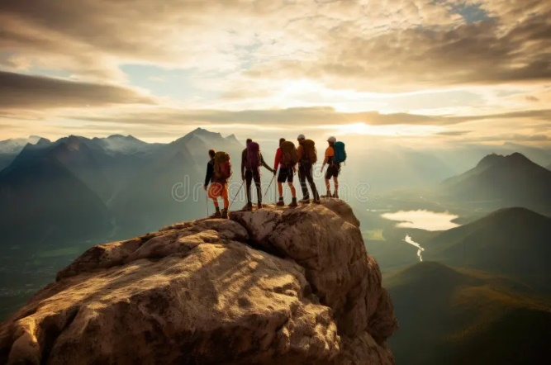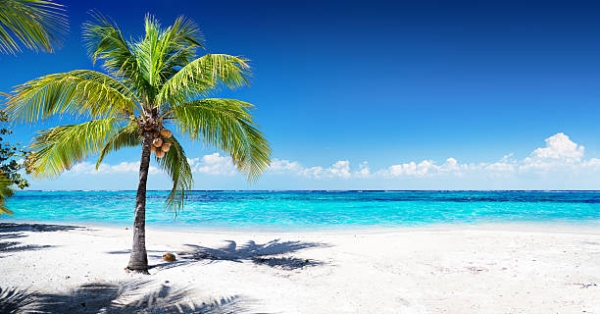

* Describe 2 pictures

In the first picture, a group of people is climbing a mountain, with rugged terrain and rocky peaks in the background. The climbers are dressed in outdoor gear, focused on their journey as they make their way up the challenging slope. The surrounding landscape is breathtaking, with vast views of nature and perhaps some distant valleys or forests.

In the second picture, there is a serene beach with no people in sight. The beach is calm and peaceful, with gentle waves lapping the shore. Several palm trees stand tall along the coastline, swaying in the breeze. The clear blue sky and the sparkling ocean create a tranquil atmosphere, perfect for relaxation and nature lovers.

* What is the attraction of those 2 places?

The mountain offers adventure, excitement, and a chance to connect with nature in a more challenging and rugged way. It attracts those who enjoy hiking, rock climbing, and the satisfaction of reaching a peak while surrounded by breathtaking views. On the other hand, the beach offers a peaceful retreat with its beautiful scenery, calm waters, and a relaxing environment, making it perfect for those who want to unwind, swim, or simply enjoy the natural beauty of the coastline.

* How to protect the natural beauty of those places?

To protect the natural beauty of both mountains and beaches, it’s important to practice responsible tourism. This includes not littering, avoiding damage to plants and wildlife, and sticking to marked trails in the mountains to prevent soil erosion. For beaches, it’s essential to keep the area clean, avoid disturbing marine life, and reduce plastic waste. Supporting sustainable practices, such as eco-friendly travel options and conservation efforts, can also help preserve these natural landscapes for future generations.

**12. 1 người đàn ông tập gym/ 2 người phụ nữ leo núi**

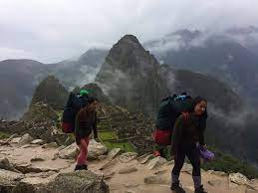

* Tả 2 tranh

In the first picture, a man is working out at a gym, lifting weights. His focus and determination are visible as he performs strength training, using gym equipment designed for building muscle. The gym is filled with various machines and weights, creating an energetic atmosphere.

In the second picture, two women are climbing a mountain. They are wearing outdoor gear, carefully navigating the rocky terrain. The landscape around them is vast and natural, with beautiful views of the mountains. The women seem to be enjoying the physical challenge of the climb, working together as they ascend the peak.

* What Is the Difference Between These Two Types of Exercise?

The main difference between gym workouts and mountain climbing is the type of physical activity involved. Gym workouts, like weightlifting, focus on building muscle strength and improving endurance through controlled movements and equipment. It’s typically done indoors and focuses on specific muscle groups. On the other hand, mountain climbing is an outdoor, full-body workout that requires cardiovascular endurance, balance, and strength, with the added challenge of navigating unpredictable terrain. While gym workouts can be more targeted, mountain climbing offers a more holistic and adventurous physical experience.

* How Important Is Regular Exercise?

Regular exercise is crucial for maintaining overall health and well-being. It helps strengthen the heart, muscles, and bones, and improves flexibility and endurance. Consistent physical activity also boosts mental health by reducing stress and anxiety, improving mood, and promoting better sleep. Whether it’s through gym workouts or outdoor activities like hiking or climbing, exercise contributes to a longer, healthier life by reducing the risk of chronic diseases like heart disease, diabetes, and obesity.

**13. Tranh 2 công nhân đeo đèn trên đầu và tranh đầu bếp cầm đĩa thức ăn vui vẻ**

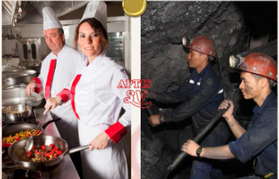

* Describe
* What is your opinion about these 2 jobs?
* Which job do you think is more interesting?
* In the first picture I can see two men cooking in the kitchen. They are wearing cooking uniforms. Moreover, they are wearing hats. I think they work at the hotel. The food looks delicious. One man is smiling. They look so happy.

In the second picture I also can see two men. I guess they are workers. They are wearing helmets with flashlights in front of them. In my opinion, this work is harder than the work in the first picture

* I think in the first picture it's a comfortable place to work. They have no pressure. But they need meticulousness. If they work at a five star hotel, they will get a high salary.

In the second picture, they work so hard. They leave early in the morning and come back when the sun goes down. They would have to focus very carefully. It might be stressful.

* I think chefs would be more fun to do. I can cook many delicious dishes. Furthermore, I can not only decorate but also create the dishes. On the weekends or holidays, I will cook for my family. I feel happy and joyful. Cooking dishes makes me reduce stress.

**14. Tranh thành phố ven biển + ngôi nhà trên núi**

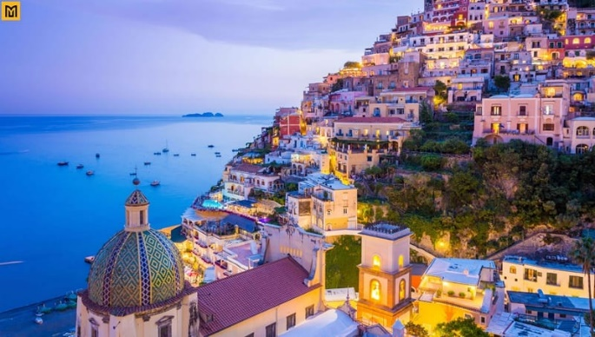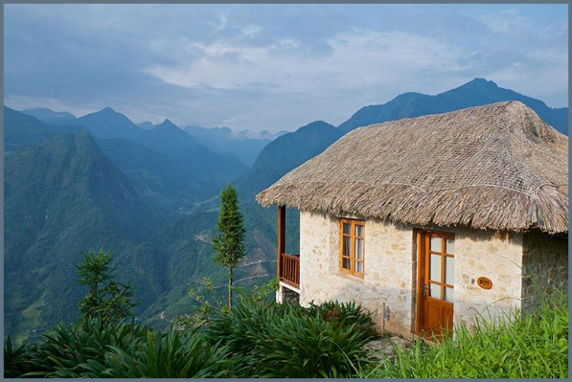

* Describe

The first picture shows a vibrant coastal city, where the skyline is filled with tall buildings and the ocean stretches into the horizon. The beach is nearby, with people enjoying the sun and water. The city appears to be bustling, with streets full of life and activity, creating a lively atmosphere. The combination of urban life and the beautiful ocean view makes the city a popular spot for both relaxation and excitement.

In the second picture, there is a tranquil house nestled on a mountain, surrounded by lush greenery and rugged terrain. The house looks isolated, offering a peaceful retreat away from the busy city life. The mountain provides breathtaking views of the valley or forest below, and the atmosphere is calm, natural, and serene.

* Which place do you prefer?

Personally, I think it depends on the kind of experience you seek. If you enjoy a fast-paced lifestyle with lots of activities, restaurants, and the beach, the coastal city would be a great choice. The dynamic environment offers convenience, entertainment, and access to the sea. However, if you’re looking for tranquility, fresh air, and beautiful natural landscapes, the house on the mountain would be the ideal choice for a peaceful escape and a connection to nature.

* Where is suitable for children?

The coastal city is likely more suitable for children, as it provides a variety of activities such as beach trips, parks, museums, and family-friendly attractions. Children can enjoy playing in the sand, swimming, or exploring the city. On the other hand, while the mountain house offers a peaceful environment, it might not have as many child-specific activities unless the children enjoy outdoor adventures like hiking, which may require more supervision and preparation.

**15. Âm nhạc hiện đại + âm nhạc cổ điển**

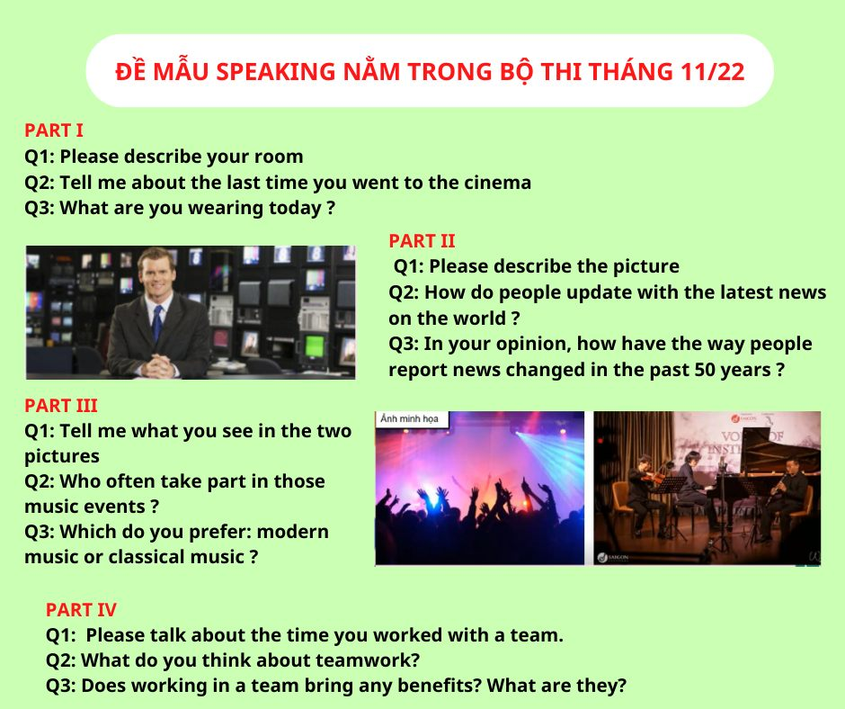

* describe

The first picture shows a lively concert scene where a crowd of people is gathered to listen to live music. The stage is brightly lit, with performers playing instruments and singing, while the audience is fully engaged, enjoying the energetic atmosphere of the live performance. The sounds of the music fill the air, creating a shared experience of excitement and connection.

The second picture shows a person playing the piano at home, with a calm, focused expression. The setting is quiet, perhaps with soft lighting and a cozy atmosphere. The person is alone, absorbed in the music, playing classical or modern pieces with skill and passion. This is a more intimate and personal music experience.

* Who Often Takes Part in Those Music Events?

Concerts are typically attended by music lovers who enjoy the thrill of live performances. People of all ages and backgrounds attend concerts, often to see their favorite artists or discover new ones. Fans of specific genres like pop, rock, or electronic music are common in such events. On the other hand, those who play musical instruments, especially pianists, often engage in playing at home, whether as a hobby or a practice session. Piano enthusiasts and musicians of various skill levels, from beginners to professionals, take part in playing music at home.

* Which Do You Prefer: Modern or Classical Music?

The preference between modern and classical music really depends on the mood and setting. Modern music is energetic, catchy, and often reflects current trends, making it perfect for a lively, social atmosphere like a concert. It’s diverse and can cover many genres such as pop, rock, or electronic. Classical music, on the other hand, offers a timeless elegance and depth, with intricate compositions that evoke different emotions. It's ideal for relaxing, focusing, or creating a more reflective environment. Both genres have their unique appeal, depending on the situation and personal taste.

**16. Cửa hàng tiện lợi + siêu thị**

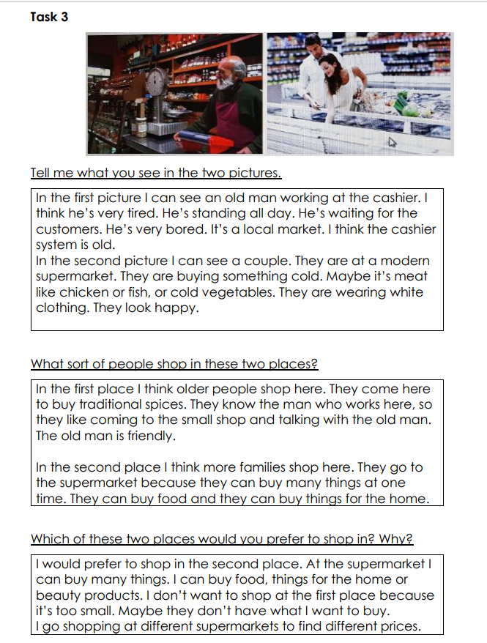

**17. Học online và offline**

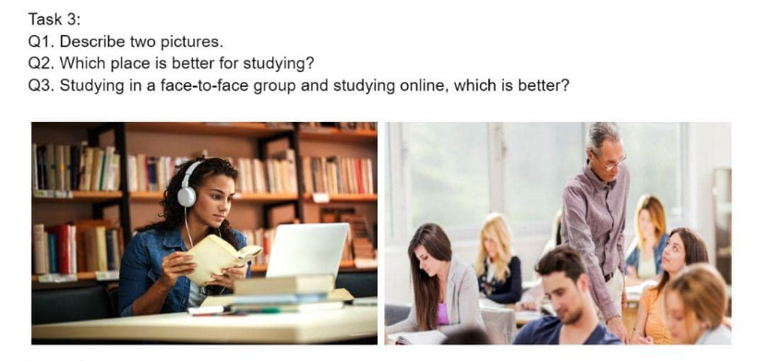

* describe

In the first scene, a person is studying online at home. They are sitting at a desk, perhaps in front of a computer or laptop, with headphones on and a focused expression. The environment is quiet, with some books and personal items around, creating a comfortable and private space for learning. The convenience of online learning allows them to attend classes or access resources from the comfort of their own home. In the second scene, students are in a classroom, engaging in face-to-face learning with a teacher. The room is filled with desks, a chalkboard or projector, and students interacting with one another and the instructor. The teacher is explaining a lesson, while the students listen and participate in discussions or activities. The classroom setting fosters a more structured and social environment for learning.

* **Which Place Is Better?**

Whether online learning at home or offline in a classroom is better depends on the individual’s preferences and learning style. Online learning at home offers flexibility, allowing students to learn at their own pace and manage their time. It’s ideal for those who prefer a quiet, self-paced environment. On the other hand, offline learning in a classroom provides direct interaction with teachers and peers, which can enhance understanding and motivate students. It is better for those who thrive in structured settings with social interaction.

* **Studying in a Face-to-Face Group vs. Studying Online, Which Is Better?**

Studying in a face-to-face group allows for better collaboration, immediate feedback from the teacher, and direct interaction with classmates, which can lead to a deeper understanding of the material. Group discussions and the social aspect of learning can be motivating and engaging. However, studying online offers flexibility, especially for those with busy schedules or those who prefer to work independently. It allows for self-paced learning, but may lack the social interaction and support of a physical classroom. The choice depends on the learner’s needs—whether they value flexibility or prefer a more interactive, structured learning environment.

**18. 2 kiểu nhà ở: apartment + small house**

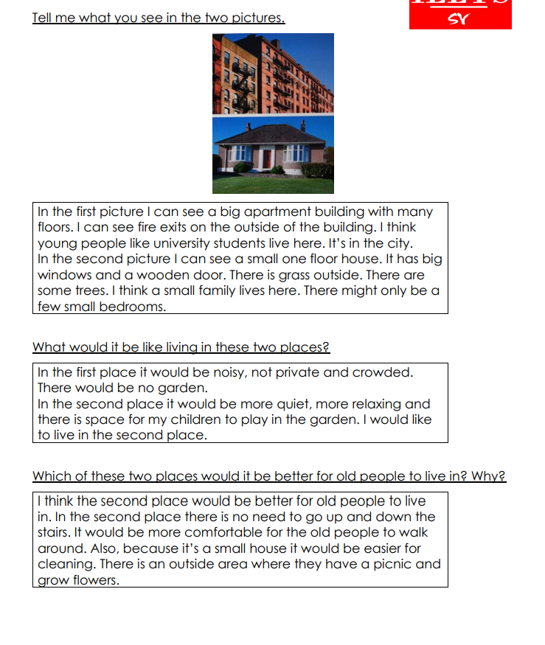

**19. Xem phim ở rạp + xem phim ở nhà**

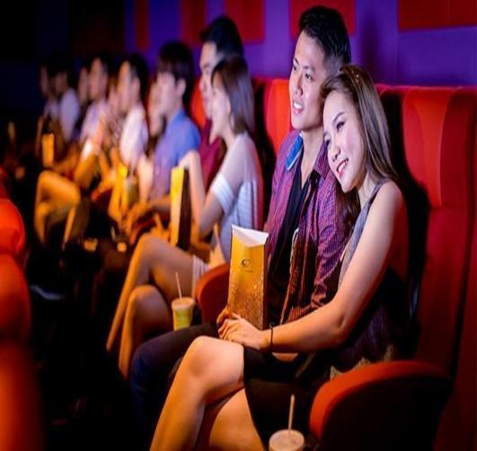

**Describe the Two Pictures**In the first picture, a group of people is watching a movie at a cinema. The theater is dark, with a large screen at the front, displaying the movie. The audience is sitting in rows, focused on the screen, with some popcorn and drinks in hand. The atmosphere is lively and immersive, with high-quality sound and visuals that enhance the movie-watching experience.

In the second picture, someone is watching a movie at home, sitting on a cozy couch with a TV screen in front. The room is comfortably lit, and the person is relaxed, perhaps with snacks or a drink. The environment is quiet and personal, offering a more casual and comfortable setting for watching movies.

**Where Do You Prefer Watching Movies? Why?**I personally enjoy watching movies at home because of the comfort and flexibility it offers. At home, I can pause the movie whenever I want, relax in my own space, and even choose what snacks I want to have. I also don’t have to worry about loud crowds or sitting in a fixed position. However, I do enjoy the cinema experience when it’s a highly anticipated movie, as the big screen, surround sound, and immersive environment can make it more exciting.

**Where Is Better to Watch Movies?**Both options have their pros and cons. Watching movies in a cinema is great for those who enjoy a cinematic experience, with high-quality visuals and sound that can make the movie feel more impactful. It’s also a fun social activity if you go with friends. On the other hand, watching movies at home is more convenient and relaxing, offering the freedom to watch at your own pace, without distractions. It’s also less expensive. Ultimately, the best place depends on what kind of experience you’re looking for: a professional, immersive experience at the cinema or a comfortable, flexible one at home.

**20. Nghe nhạc bằng headphone ở nhà + nghe ca sĩ hát ở ngoài**



* Describe

Well, both of these two pictures show us some people enjoying music but they have several differences. In the first picture, there is a woman lying on a chair and listening to music. I guess she is enjoying her leisure time by listening to his favorite songs. Maybe she is a huge fan of music. Music helps her feel relaxed and comfortable. In the second picture, I see a group of people playing with musical instruments. I guess they're professional musicians and they are preparing for their upcoming concert. Maybe music is their passion and it becomes an important part of their life.

* The ways to enjoy music in these 2 pictures?

The ways to enjoy music in these two pictures are so different. In the first picture, the woman is enjoying music herself at home. To enjoy the relaxing time with music, everything she needs just is a smartphone or a music player and headphones. That’s it. She can lie down on the chair whenever she wants and listen to any favorite songs. Awesome. In the second picture, it may be a professional concert that needs preparation well before starting. If you want to go to a music concert, you need to find a suitable one that will perform your favorite type of music and book the ticket early to reserve. It seems a bit more complicated.

* Benefits of listening to music

Music is an important part of being human. First, music helps us improve our mood. Music can benefit overall well-being and create happiness in everyday life. Secondly, music reduces stress and anxiety in people's minds. Third, music improves memory and eases pain. I am not a huge fan of music at all but I think people can't live without music. Especially, when I feel disappointed or losing myself, music helps to find me again.

**21. Người đàn ông ngồi đọc sách + Cậu bé chơi điện tử**

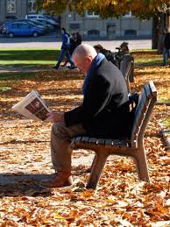

**Describe the Two Pictures**In the first picture, a man is sitting comfortably, deeply focused on reading a book. He is seated in a quiet environment, perhaps with a warm drink by his side, creating a peaceful, thoughtful atmosphere. The man appears to be absorbed in the story or information, enjoying the solitude and focus that comes with reading.

In the second picture, a boy is playing video games. He is sitting in front of a screen, likely holding a game controller, and seems fully immersed in the game. The room is well-lit, and there may be some gaming accessories or posters around. The boy looks engaged in the action of the game, enjoying the fast-paced and interactive experience.

**Do You Prefer Reading Newspapers or Playing Video Games?**It really depends on the mood and the context. Reading newspapers can be a great way to stay informed about current events and expand knowledge, while playing video games offers an exciting and interactive form of entertainment. Personally, I enjoy reading to stay updated on news or to dive into a good book for relaxation. However, video games are a fun way to unwind and engage with others in a virtual world. Both have their own value, depending on what you're looking to do at the moment.

**What Are the Benefits of Reading?**Reading has numerous benefits, including expanding vocabulary, improving concentration, and enhancing knowledge. It can also boost creativity, stimulate the brain, and improve critical thinking skills. Reading books or articles helps individuals understand different perspectives and can serve as an escape, providing relaxation and stress relief. It’s a powerful way to learn new things, improve writing skills, and enhance overall cognitive function.

**22. Rừng thông + Sa mạc**

Tranh 1 người đàn ông đứng ở rừng thông lạnh giá + Người phụ nữ đứng ở sa mạc

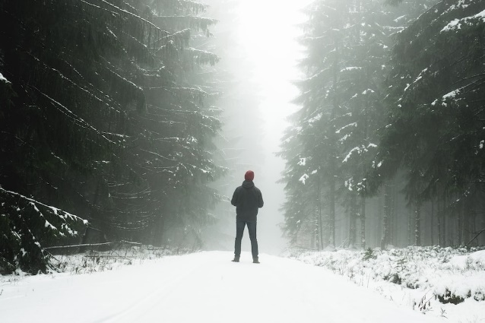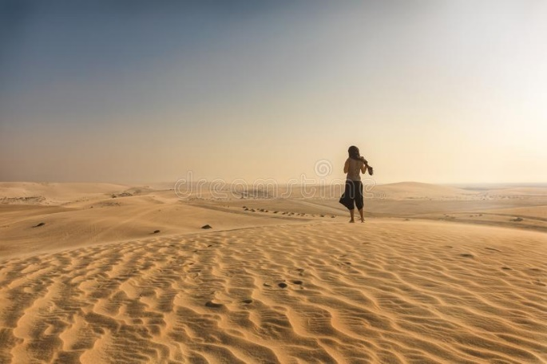

**Describe the Two Pictures**In the first picture, a man stands in a dense, snow-covered pine forest. The tall trees are thick with snow, and the atmosphere feels cold and quiet. The man is dressed warmly, perhaps in a jacket and gloves, to protect himself from the freezing temperatures. The environment looks isolated, with the stillness of the snow-covered forest adding to the sense of peace and solitude.

In the second picture, a woman stands in a vast desert. The sand stretches for miles, with no signs of vegetation except a few scattered plants. The sun is harsh, and the landscape appears dry and barren. The woman is dressed in light, protective clothing, perhaps to shield herself from the heat and sun. The desert is expansive and open, with a sense of openness and quiet.

**What Types of People Live in These Two Places?**People who live in cold, snowy environments like pine forests are often accustomed to harsh weather conditions. These individuals might be involved in activities like logging, research, or tourism, and they need to be prepared for extreme temperatures. Their lifestyle is typically built around staying warm, often in remote, isolated areas where the natural environment plays a major role in daily life.

In contrast, people living in the desert are usually adapted to hot, dry conditions. Many desert communities rely on agriculture, especially those who use irrigation systems, and some might work in mining or tourism. Their lifestyles involve strategies for managing extreme heat, such as using light clothing, finding sources of water, and adapting to the sparse environment.

**Which Place Do You Prefer?**It really depends on the lifestyle I enjoy. The snowy pine forest offers tranquility and a close connection to nature, ideal for those who appreciate solitude, winter activities, and the beauty of snowy landscapes. On the other hand, the desert has its own kind of beauty, with wide open spaces and unique environments. It might be more appealing for those who enjoy warmth, vast landscapes, and a sense of adventure. Personally, I would prefer the pine forest for its peaceful, serene atmosphere and the chance to enjoy winter activities.

**23. Người đàn ông với đàn khỉ + Ngư dân bắt cá heo**

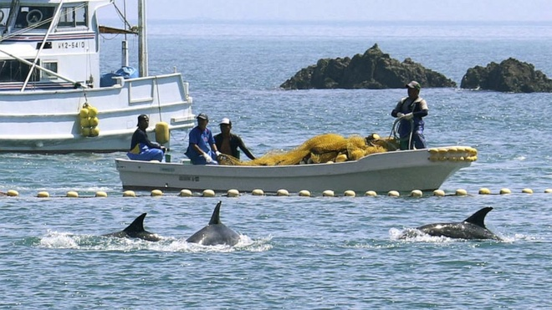

* Describe

Well, these two pictures are so beautiful, I like them so now I can describe them. Looking at the first picture, I can see a man and three monkeys. They are playing. They are happy. This is my description for the first one.

Moving to the second picture, I can see a man playing with a dolphin. They are happy.

This is my description for the second one.

So, they have something in common. They are about animals. But they are different monkeys and dolphins. Anyway, I like both pictures because……………………

* Do you prefer monkeys or dolphins?

I think both are amazing, but it depends on what you’re into! Monkeys are super intelligent and social, and their playful behavior is fascinating. They can learn and adapt to different environments, which makes them really interesting to watch. On the other hand, dolphins are incredible swimmers, and their ability to communicate with each other is mind-blowing. They form tight bonds and even help each other out in the wild. It’s tough to choose, but I guess I’d lean towards dolphins for their intelligence and the fact they live in such a mysterious environment!

* What should we do to protect animals?

Protecting animals is really important, and there are a lot of things we can do. First, we need to stop destroying their natural habitats—things like deforestation and pollution have a huge impact on wildlife. Protecting forests, oceans, and other ecosystems is key. We should also support conservation efforts, like wildlife reserves and breeding programs for endangered species. Reducing plastic waste, fighting climate change, and even making more sustainable choices in our daily lives can all make a difference. Every little effort counts when it comes to protecting animals and the planet!

**24. Gia đình chơi cờ + Một người chơi video games**

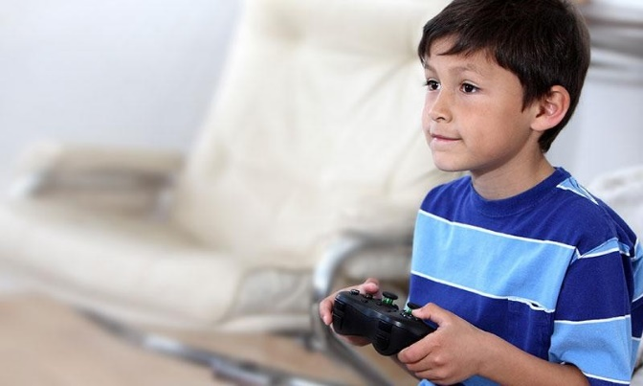

**Describe the Two Pictures**In the first picture, a family is gathered around a table playing chess. The atmosphere is calm and thoughtful, with each member of the family focused on their moves. The family members are likely engaged in a friendly yet competitive game, enjoying quality time together. The setting is cozy, perhaps in a living room, with a warm and peaceful ambiance.

In the second picture, a boy is playing video games, sitting in front of a screen with a game controller in his hands. He looks concentrated and immersed in the game. The room is well-lit, with gaming accessories around him, reflecting the modern, interactive world of video gaming. The boy is enjoying the fast-paced action of the game.

**Do You Prefer Playing Chess or Playing Video Games?**It depends on the mood and what I want from the activity. Chess offers a more strategic and slow-paced experience, which requires concentration, thinking ahead, and careful planning. It’s a great way to challenge the mind. On the other hand, video games offer excitement, entertainment, and sometimes a social experience, especially if you’re playing online with others. Personally, I enjoy both, but I might lean towards chess when I want to relax and think deeply and video games when I want action and fun.

**Are Indoor Activities Important? Why?**Yes, indoor activities are very important for a variety of reasons. They provide a way to relax and unwind, especially when the weather outside is not suitable for outdoor activities. Indoor activities like reading, playing chess, or even playing video games can help improve cognitive skills, provide entertainment, and offer a space for socializing with family or friends. They are also essential for learning new skills and keeping the mind engaged, particularly during times when it’s difficult to be outside, such as during the winter or bad weather.

**25. Cưỡi lạc đà + Cưỡi xe ngựa**

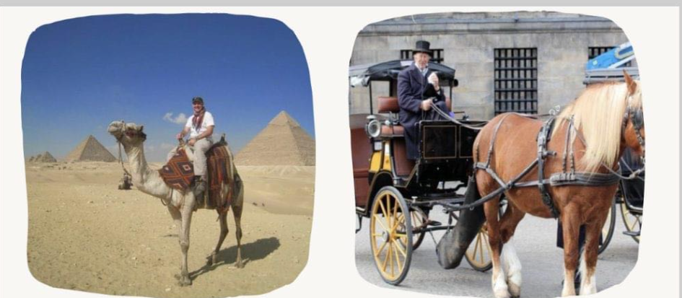

* Describe

Looking at these two pictures, I can see two different ways of moving with animals.

Looking at the picture on the left, I can tell that there is a man riding a camel. It seemed like he was in the desert because there was a pyramid behind him and all around was golden sand.

Looking at the picture on the right, I see a man riding a horse-drawn carriage. He wore a very elegant suit. It seems like he's in town.

* What are the interesting points of these 2 ways of traveling above?

Riding a horse or camel is interesting because these animals make the journey special. Horses are fast and make the trip exciting, creating a strong bond with the rider. Camels are great for slower, relaxed journeys, letting travelers enjoy the surroundings. Both experiences connect people with animals, adding a unique touch to the trip. Riding horses or camels also lets us feel a connection to history, culture, and nature, making the journey more memorable and meaningful.

* Should animals be treated like a means of transportation?

I think animals shouldn't just be used as a way to get around. Even though they can help us travel, we need to be kind to them. Animals have feelings and needs, so it's not fair to treat them only as a transportation tool. Taking care of them means giving them enough rest and not making them work too much. We should be nice to animals and make sure they are treated well while still using them for transportation.

**26. Ăn ở nhà + Ăn ngoài hàng**

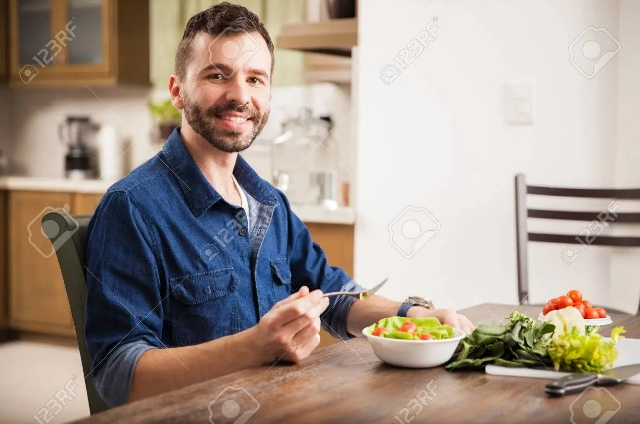

**Describe the Two Pictures**In the first picture, a man is sitting at a table at home, enjoying a homemade meal. The setting is warm and cozy, with the table filled with delicious dishes, creating a comfortable atmosphere. The focus is on the food, and the meal appears to be a home-cooked, nourishing experience, perhaps prepared with care by family members.

In the second picture, people are eating at a restaurant. The setting is lively, with neatly arranged tables, and the food is presented professionally. The atmosphere is busy, with waiters serving customers, and the dining experience is more social. The people seem to be enjoying their meal in a more public setting, possibly as part of a celebration or casual outing.

**Do You Prefer to Eat at Home or Out?**I enjoy both eating at home and dining out, but it depends on the situation. Eating at home is more comfortable, cost-effective, and allows for home-cooked meals, where I can control the ingredients and portion sizes. It’s also a great way to spend quality time with family. On the other hand, dining out offers variety, new experiences, and the chance to try different cuisines, which is exciting. For a regular meal, I prefer eating at home, but for special occasions, dining out can be fun and enjoyable.

**Why Do We Have to Eat a Variety of Foods?**Eating a variety of foods is important because it ensures that we get a wide range of nutrients essential for maintaining good health. Different foods provide different vitamins, minerals, proteins, and fats that our bodies need to function properly. A balanced diet with a variety of foods can help prevent nutritional deficiencies, promote overall well-being, and reduce the risk of health problems like obesity or heart disease. It also keeps meals interesting and enjoyable, allowing us to experience different flavors and textures.

**27. Người khuyết tật chơi bóng rổ + Người già chơi tennis**



**Describe the Two Pictures**In the first picture, a person with a disability is playing basketball in an indoor gym. They are skillfully maneuvering the wheelchair to navigate the court, showcasing determination and athleticism. The gym has a competitive and encouraging atmosphere, and the person is focused on the game, demonstrating how adaptive sports provide opportunities for all individuals, regardless of physical limitations.

In the second picture, an elderly person is playing tennis outdoors. They are actively engaged in the game, enjoying the fresh air and sunshine. The tennis court is surrounded by greenery, providing a peaceful yet energetic environment. The elderly player is moving with agility, highlighting the fact that age is not a barrier to participating in sports and enjoying physical activity.

**What Are the Benefits of Indoor and Outdoor Sports?**Indoor sports, like basketball or badminton, offer the advantage of being weather-independent, providing a controlled environment where individuals can play year-round. They also tend to be more predictable, with no weather-related interruptions. Indoor sports can be excellent for training, focus, and competition in a comfortable space.

Outdoor sports, on the other hand, allow for fresh air, sunshine, and exposure to nature, which can improve mood and mental health. Playing outdoors often involves more space and can enhance physical endurance, offering a greater variety of settings (such as tennis, soccer, or hiking). Both types of sports provide physical exercise, but outdoor sports have the added benefits of connecting with nature and improving overall well-being.

**Do You Think That the Main Purpose of Playing a Game Is to Win?**While winning is a natural goal in any competitive game, I believe the main purpose of playing a game should be about enjoyment, personal growth, and teamwork. Games help develop skills, foster social connections, and promote physical activity. They provide an opportunity to challenge oneself, build resilience, and learn how to work with others. Of course, winning adds excitement and a sense of accomplishment, but the true value of playing a game lies in the experience and the lessons learned along the way.

**28. Đọc sách truyền thống + đọc sách online**



**Describe the Two Ways of Reading**In the first picture, a person is reading a traditional paper book, enjoying the experience of turning physical pages in a calm and focused setting. This provides an immersive, distraction-free way to read. In the second picture, a person is reading on a digital device like a tablet. The device offers portability, customization of text, and easy access to multiple books, but it may lack the tactile satisfaction of a physical book.

**What Are the Disadvantages of These Two Ways of Learning?**Traditional books can be bulky, expensive, and less convenient to carry around. They can also take longer to search for specific information compared to digital formats. Digital reading, while portable, can cause eye strain, distractions from notifications, and sometimes make it harder to retain information. Some may also find that screen reading reduces the immersive experience of physical books.

**Nowadays, Technology Has Helped Us a Lot in Finding Information, What Do You Think?**Technology has made accessing information much easier and faster. The internet offers a wealth of resources, and online platforms have made learning interactive. However, it’s important to ensure the sources we use are reliable and accurate. While technology has improved learning, we must be careful to avoid misinformation and use it responsibly.

**30. Chơi bóng đá + nhảy xà**



* Describe

Looking at these two pictures, I see that there are two different sports.

Looking at the picture on the left, I see there is a soccer team. They are playing soccer on the grass field and it looks like they are playing in a stadium.

In the picture on the right I see a man doing jumps. He's wearing a sporty outfit and he looks very healthy and full of energy. In this picture, I can see the weather is very lovely and brilliant.

* What is the difference between these 2 sports activities?

Football and high jump are different sports. Football is a team game with a ball, played by two teams. The goal is to score by getting the ball into the opposing team's goal. In high jump, individuals try to jump over a bar. Football is about teamwork and scoring goals, while high jump is an individual sport where athletes show their ability to jump over a bar. The main difference is that football is a team game, and high jump is an individual event in track and field.

* Why are some sports activities more popular than others?

Certain sports are more well-liked because they're easy to try, get a lot of attention in the media, and connect with people culturally. When a sport is simple to start, doesn't need much gear, and is widely covered in the media, it tends to become popular. The cultural importance and traditions associated with a sport also matter. Moreover, sports that are easy to understand and play often attract more people. In summary, a sport's popularity depends on how accessible it is, its media exposure, cultural relevance, and simplicity.

**31. Bảo tàng + đu dây**

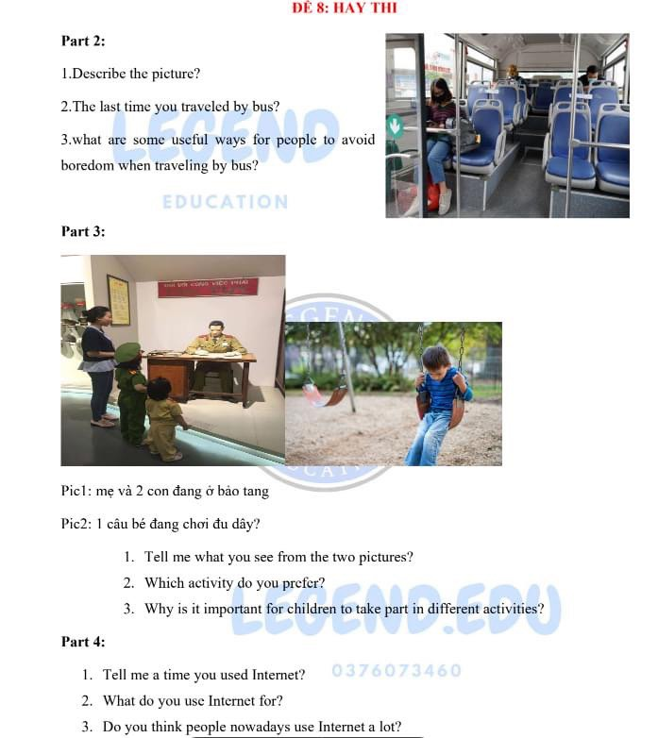

**Describe the Two Pictures**In the first picture, a mother and her two children are visiting a museum. They are likely looking at exhibits, with the children observing and the mother guiding them through the displays. The museum appears to be a place of learning, where the family is exploring history, art, or science in an educational environment.

In the second picture, a young boy is playing on a swing in a park. He is enjoying the thrill of swinging back and forth, with a joyful expression. The park is outdoors, and the boy looks active, surrounded by greenery and open space, showing the carefree enjoyment of physical play.

**Which Activity Do You Prefer?**Both activities are enjoyable, but I would prefer visiting the museum. It’s an excellent way to learn new things, especially in a family setting. Museums provide opportunities for cultural and educational enrichment, which is always exciting. However, playing in the park is also fun and a great way to stay active. It really depends on the mood and the type of experience I'm looking for!

**Why Is It Important for Children to Take Part in Different Activities?**It’s important for children to engage in various activities because it helps them develop a range of skills, from cognitive abilities to physical coordination. Visiting a museum can stimulate intellectual curiosity, creativity, and knowledge, while playing in the park encourages physical fitness, social interaction, and emotional development. A variety of experiences supports well-rounded growth, helping children explore their interests and develop a balanced set of skills for life.

**32. Chơi piano ở nhà + Chơi guitar trên sân khấu**

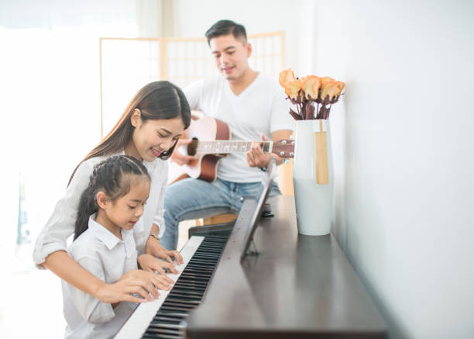

**Describe the Two Pictures**In the first picture, a person is playing the piano at home. The setting is cozy, with soft lighting, and the person appears focused on the keys. The atmosphere feels calm and intimate, allowing the player to enjoy the music in a relaxed, personal space.

In the second picture, a person is playing the guitar on stage in front of an audience. The setting is lively, with bright stage lights shining on the performer. The crowd is visible, and the performer seems confident, surrounded by a more energetic and public environment. The performance is likely a mix of excitement and focus as the musician shares their talent with others.

**Where Do You Like to Play Music? Why?**I enjoy playing music both at home and on stage, but it depends on the experience I’m looking for. At home, I like the quiet and personal atmosphere where I can practice and get lost in the music without any pressure. It’s a time for self-expression and relaxation. On stage, the energy of the crowd and the excitement of performing create a different kind of thrill. It’s an opportunity to share the music with others and feel the connection through performance.

**How Does Playing Music in Different Locations Bring Different Feelings?**Playing music at home feels more private and peaceful. It allows you to focus on the music itself and explore emotions without distractions. On the other hand, playing music on stage brings a rush of adrenaline and excitement. The audience's reactions add a sense of accomplishment and connection, but there’s also more pressure to perform well. The location changes the mood of the music, whether it's calming at home or dynamic and energizing on stage.

**33. Ăn vỉa hè + ăn nhà hàng**

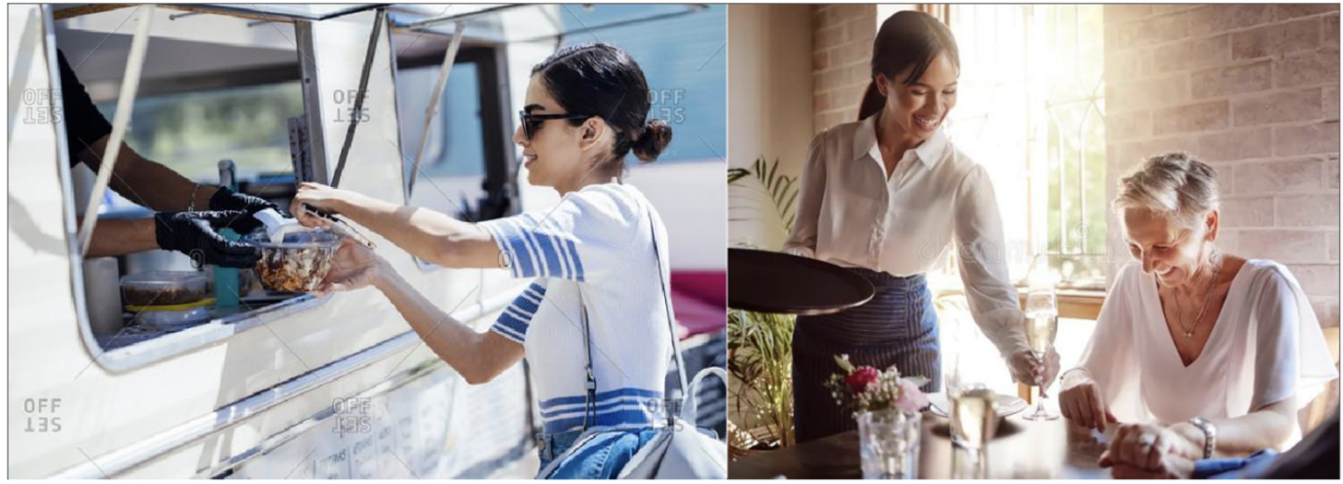

**Describe the Two Pictures**In the first picture, people are sitting at a street food stall, eating delicious dishes from plastic tables along the sidewalk. The atmosphere is casual and lively, with the sounds of the street surrounding them. The food is served quickly, and the experience is typically inexpensive and relaxed, but the environment may be crowded and noisy.

In the second picture, people are dining at a fancy restaurant. They are seated at elegant tables, with high-quality service and a calm atmosphere. The restaurant is clean and well-organized, offering a more refined and formal dining experience, but the meals tend to be more expensive and may take longer to prepare.

**What Are the Difficulties of Eating in These Places?**Eating at a street food stall can be uncomfortable due to the lack of seating, limited privacy, or noise from the street. The cleanliness and hygiene might also be a concern for some. While the food is often tasty and affordable, the lack of amenities or comfort can make the experience less pleasant.

Eating at a restaurant may have fewer physical discomforts, but it can be expensive and time-consuming. The formal setting might also feel intimidating or less relaxing for those who prefer a more laid-back dining experience. Long waiting times or complex menus might also be a downside.

**Why Do People Dislike Eating Alone?**Many people dislike eating alone because it can feel isolating or uncomfortable. Eating is often a social activity, and sharing a meal with others can make the experience more enjoyable and fulfilling. Being alone might lead to feelings of loneliness, and people may feel self-conscious in a public setting without company. Additionally, meals are a time for conversation and connection, which can be missing when dining alone.

**34. Làm việc ở phòng thí nghiệm + văn phòng**

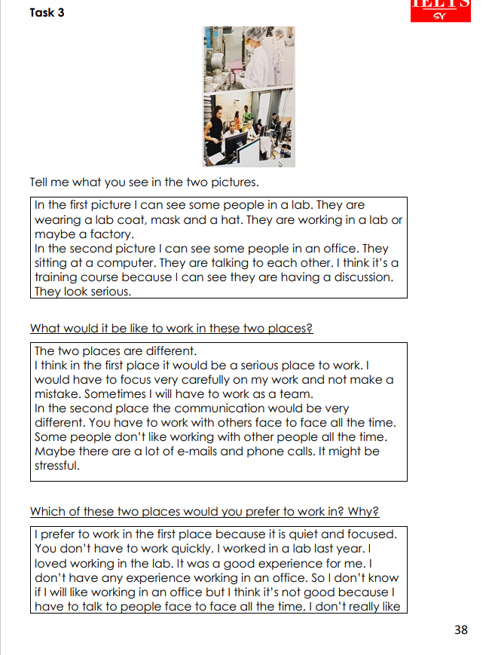

**35. Rừng thông + Bãi biển**



* Describe

In these two pictures, I see two completely different places.

In the first picture, I see two people standing in a pine forest. The weather looks very cold. Looking at the background, I see a lot of pine trees around.

In the second picture, I see two people sitting and looking at the sea. They seem to be relaxing and enjoying themselves very much. It seems that the beach is very beautiful and the weather is very lovely and gorgeous.

* Which place do you like more? Pine forests or beaches?

I prefer beaches. People love beaches for their calming vibes. The gentle sound of waves, warm sand, and wide sea views create a peaceful atmosphere that helps folks unwind. Beaches offer a break from the usual routine, giving a sense of escape and a chance to connect with nature. Plus, there's the fun factor – swimming or playing beach games adds to the enjoyment. The positive feelings associated with the coastal setting make beaches a top choice for those seeking a relaxing getaway from the daily grind.

* Does the weather affect people's emotions? Why?

Yes, weather can impact people's emotions. Sunny days often boost mood and energy levels, triggering positive emotions. On the other hand, gloomy weather can lead to feelings of sadness or lethargy. Natural light affects the production of serotonin, a neurotransmitter linked to mood. Additionally, seasonal changes can influence emotional states, with sunlight exposure playing a role in regulating circadian rhythms. Overall, weather conditions have a significant influence on people's emotional well-being by affecting neurotransmitter levels and daily rhythms.

**36. Gia đình ở biển + núi**

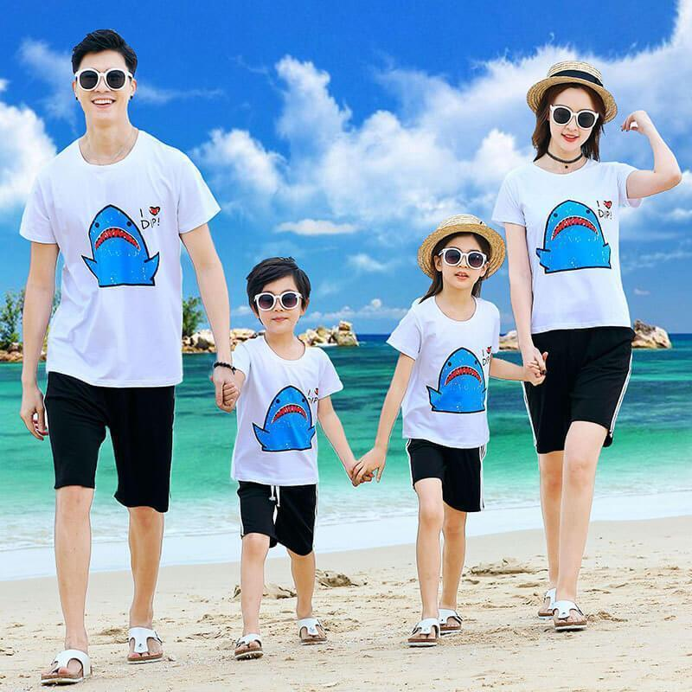

* Describe

Looking at these two pictures, I see two different activities.

In the first picture. I see a group of people climbing a mountain. Looking at the background, there are a lot of clouds and the sky is very beautiful. They seem to be professional climbers. In the second picture, I see a family at the beach looking very happy and full of energy. I can see that the weather was very beautiful and brilliant.

* Which of the 2 places do you like to go? Why?

I find the mountains more appealing. The serene landscapes and fresh mountain air create a peaceful ambiance that resonates with me. I appreciate the opportunity to hike and explore nature trails, immersing myself in the tranquility of the surroundings. While beaches are lovely, I'm drawn to the rugged beauty and sense of solitude that mountains offer. The idea of cozy mountain retreats and breathtaking views adds to the allure. Overall, the mountains provide a retreat where I can disconnect and recharge amidst the beauty of nature.

* Who is suitable for each activity? Why?

It really depends on personal preferences and interests. Beaches are great for those who enjoy sunbathing, water activities, and a more laid-back atmosphere. People who love the sound of waves, sandy shores, and a tropical vibe would likely prefer beaches. On the other hand, mountains cater to individuals who appreciate hiking, nature walks, and a cooler climate. Those seeking adventure, stunning landscapes, and a quieter retreat might find mountains more suitable.

**37. Xây cầu ở thành thị + Cánh đồng nông thôn**

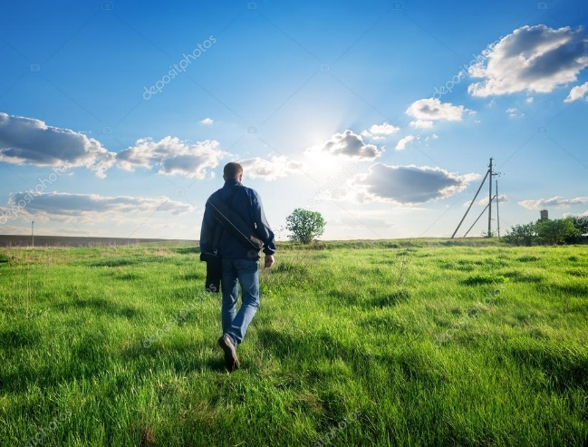

**Describe the Two Pictures**In the first picture, a group of workers is constructing a bridge in an urban setting. They are busy with various tools and machinery, working on the project in a bustling city environment. The surroundings are filled with tall buildings, roads, and traffic, indicating a fast-paced, industrial atmosphere.

In the second picture, a man is standing and looking at a peaceful rural landscape. He is observing vast fields, rolling hills, and greenery, with no signs of buildings or urban life. The environment feels calm and quiet, offering a stark contrast to the urban scene in the first picture.

**Which Place Would You Rather Live: The City or the Countryside?**I would prefer to live in the countryside. It offers a slower pace of life, fresh air, and natural beauty, which can be very relaxing and peaceful. The rural environment provides a sense of connection to nature, and I appreciate the calmness and space it offers. However, I can understand why some people prefer the city for its convenience, opportunities, and vibrant social scene.

**Who Is Suitable for Each Place? Why?**The city is suitable for people who thrive in fast-paced environments, enjoy socializing, and seek career opportunities. Those who like convenience, access to services, and entertainment will also feel at home in the city. It is perfect for professionals, young people, or anyone looking for excitement and progress.

The countryside is better for people who value peace, nature, and a slower lifestyle. It suits individuals who enjoy outdoor activities, farming, or those looking for a more relaxed pace. Retirees, families, or anyone seeking a break from the stress of city life might find the countryside more ideal for their lifestyle.

**38. Đi bằng ô tô + tàu**

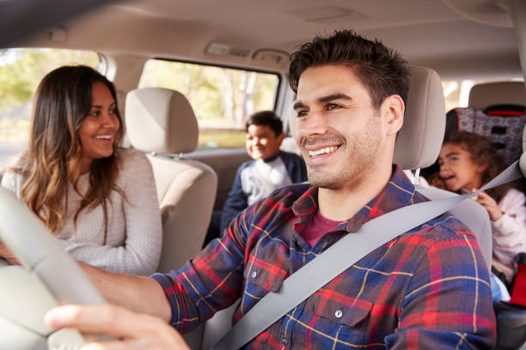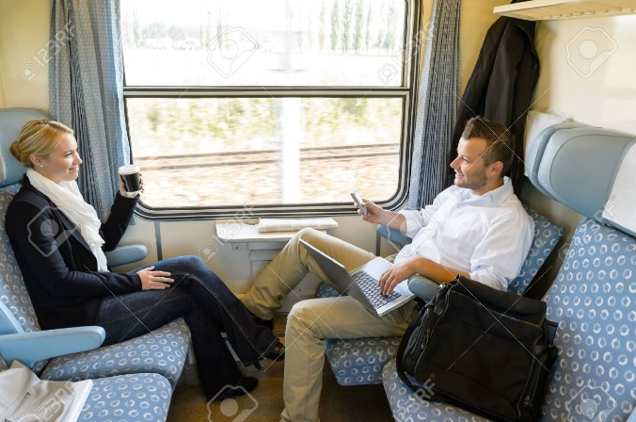

**Describe the Two Pictures**In the first picture, a family is traveling by car. They are likely on a road trip, with the car packed and everyone enjoying the journey together. The environment seems to be an open road, and the family is relaxed, sharing the experience of traveling in the comfort of their vehicle.

In the second picture, two people are traveling by train. They are seated comfortably in a train car, possibly looking out the window or having a conversation. The train offers a smooth and scenic journey, with a view of the passing landscape, suggesting a more leisurely and peaceful travel experience compared to the car.

**What Are the Advantages of Traveling by Car and Traveling by Train?**Traveling by car offers flexibility, allowing you to stop whenever you want and travel at your own pace. It's perfect for families or groups who want privacy, control, and convenience, especially on long road trips. Additionally, a car allows access to remote or rural destinations that may not be easily reachable by public transport.

Traveling by train is more relaxing, as it offers a smooth ride and the ability to enjoy the scenery without worrying about navigation or driving. Trains are often more eco-friendly and comfortable for long-distance travel. They also avoid traffic and can offer a social environment, where passengers can move around, eat, or even sleep comfortably.

**Why Do Some People Like Traveling by Train?**Many people enjoy traveling by train because it is less stressful than driving or flying. The ride is generally more relaxed, with the ability to stretch out, walk around, or use onboard services. Trains can offer stunning views of the landscape, providing a scenic journey. Additionally, traveling by train is more environmentally friendly and often more reliable than other modes of transport, making it a popular choice for both long and short trips.

**39. Bãi biển đông người + 2 cô gái cạnh sông**

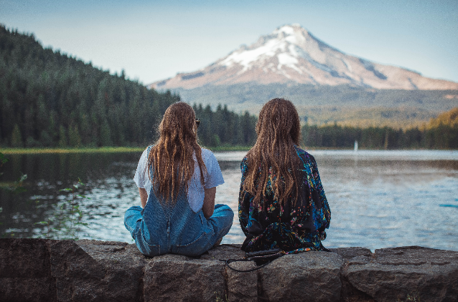

* Describe

Looking at these two pictures, I see two different places to travel.

looking at the first picture, I see a lot of people at the beach and there are a lot of umbrellas with many colors. It seems to be a very beautiful beach with blue water and white sand. I believe the weather is lovely and gorgeous. Looking at the second picture, I see two girls sitting next to a river. I guess these two girls are sitting and watching the mountains and forests to relax. This picture is very peaceful.

* Do you like going to crowded beaches?

No, I don't like going to crowded beaches. First, they are often noisy. There is a lot of noise from people talking, laughing, and playing music. This can be very distracting and make it difficult to relax. Second, crowded beaches are often dirty. There is a lot of trash and litter on the sand and in the water. This can be unsightly and even dangerous. Third, crowded beaches can be uncomfortable. It can be difficult to find a place to sit or lay down, and the sand can be hot and uncomfortable.

* Why do many people like quiet places?

People like quiet places because they offer a calm and focused environment. Silence helps with concentration and minimizes distractions, making it easier to study, read, or think deeply. A quiet setting also promotes relaxation and reduces stress. When it's quiet, people can concentrate better on their tasks, which improves productivity. The preference for quiet places is often based on the desire for a peaceful and comfortable atmosphere that supports various activities without interruptions.

**40. Học ở thư viện + ở quán cà phê**

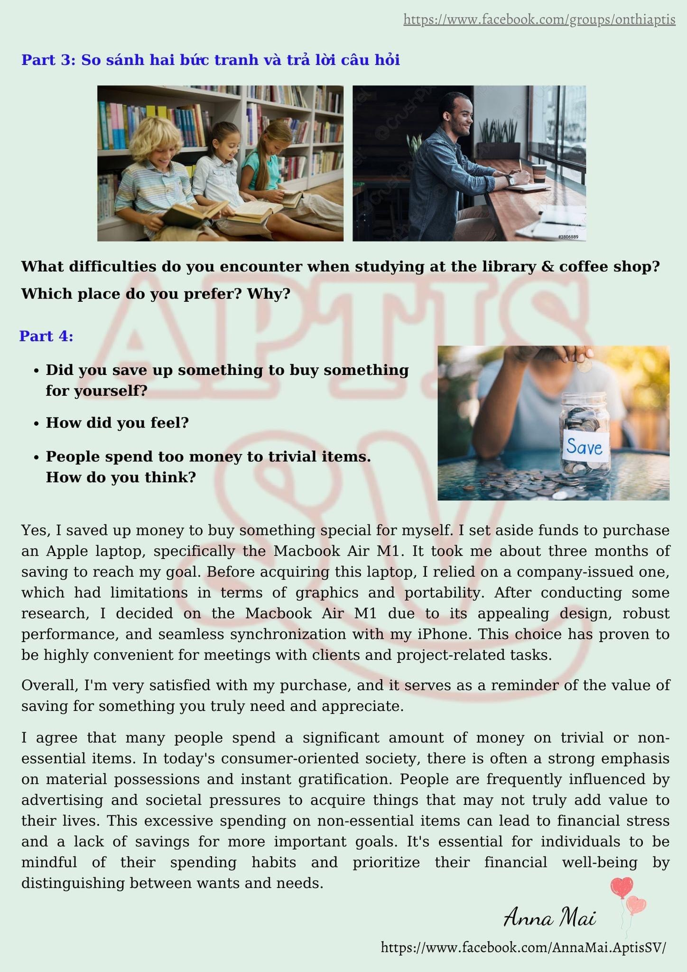

* Describe

In these two pictures, I see two different places to study. Looking at the first picture, I see 3 friends, they are wearing different casual clothes. I see that they are studying very hard. Looking at the background, I believe this is a library with a lot of books. Looking at the second picture, I see a man reading a coffee shop book. He is wearing a striped shirt. I saw that he was sitting next to the window of the cafe. Outside, the weather is very nice.

* Do you prefer studying in the library or coffee shop? Why?

I prefer studying in the library. Libraries are quiet and free, which helps me to focus on my work. They also have a variety of resources, such as books, articles, and computers, which can be helpful for research. However, I sometimes study in coffee shops. Coffee shops can be a social and welcoming environment. They also have free Wi-Fi, which can be helpful if I need to access online resources. In the end, the best place to study depends on my individual needs and preferences. If I need to focus on my work, I will study in the library. If I want to be more social, I will study in a coffee shop.

* What are the difficulties of studying at the library and at coffee shops?

Studying at a library can sometimes be challenging due to the rigid, quiet atmosphere, which may feel restrictive for some. On the other hand, coffee shops might pose difficulties with noise distractions and limited space. Libraries may lack the comfortable amenities that coffee shops provide, like refreshments. However, coffee shops may have inconsistent Wi-Fi or too much ambient noise. The choice depends on personal preferences, balancing the need for a quiet, focused environment with the desire for a more relaxed and comfortable setting.

**41. Gia đình ngồi sân cỏ + cô gái ở ban công**

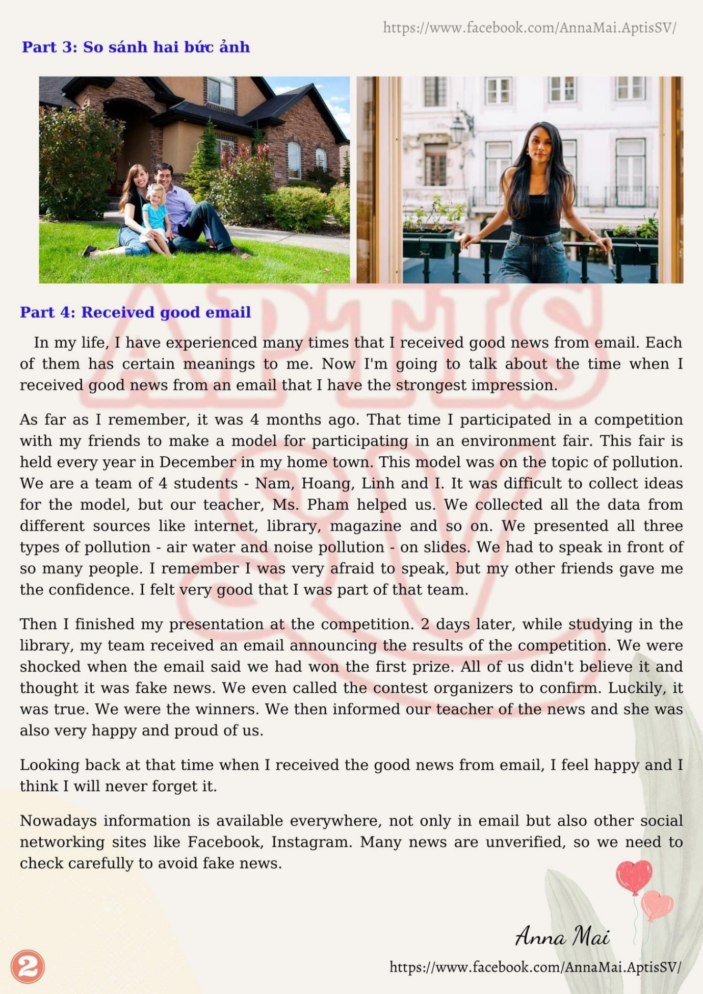

**Describe the Two Pictures**In the first picture, a family is sitting on the grass outdoors, possibly enjoying a picnic or just spending quality time together. They seem relaxed and happy, with the peaceful green surroundings providing a calm atmosphere for bonding. The scene suggests a warm, enjoyable moment shared by family members in nature.

In the second picture, a girl is sitting on a balcony, perhaps enjoying a cup of coffee or reading a book. The balcony offers a view of the outside, and the setting seems private and serene. The girl appears to be enjoying some quiet time alone, reflecting or unwinding in her personal space.

**Do You Prefer Living with Family or Living Alone?**I prefer living with family because it provides a sense of connection, support, and warmth. Being with family allows for shared moments, such as meals and conversations, and creates a more lively and social environment. However, I can also see the appeal of living alone, as it offers independence and personal space. It ultimately depends on the situation, but I value the closeness of family living.

**Nowadays, Why Do Many People Like to Live Alone?**Many people enjoy living alone for the independence it provides. It allows them to have more control over their environment, daily routines, and decisions. Living alone can also offer privacy, peace, and the freedom to personalize their space without needing to compromise with others. For some, it’s a way to gain a sense of self-reliance and enjoy solitude, which can be refreshing in today’s busy, social world.

**42. Vườn trồng cà chua (rau) + trồng hoa**

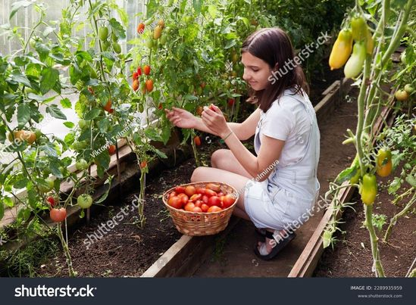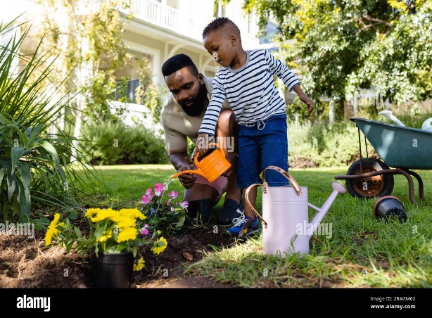

**Describe the Two Pictures**In the first picture, there is a garden full of tomato plants, with rows of healthy, ripe tomatoes growing on the vines. The garden looks neat and well-maintained, showcasing the hard work and care that goes into growing vegetables. The setting is likely sunny, with a focus on cultivating food for personal consumption or sharing with others.

In the second picture, there is a garden filled with vibrant flowers in various colors. The flowers are in full bloom, creating a beautiful and colorful display. This garden gives off a peaceful, aesthetic vibe, and the flowers likely attract bees, butterflies, and other pollinators. The focus here is on creating a visually pleasing environment rather than growing food.

**What Are the Benefits of Growing a Garden?**Growing a garden offers several benefits, such as providing fresh, organic produce for personal consumption. Gardening can also promote physical activity, improve mental health by reducing stress, and provide a sense of accomplishment. A garden allows people to connect with nature, learn new skills, and create a peaceful outdoor space. It can also help save money on groceries by growing your own vegetables or flowers.

**What Is the Appeal of Growing Vegetables or Flowers?**Growing vegetables appeals to many because it allows people to enjoy homegrown, fresh, and healthy food, often without the use of pesticides. It’s also satisfying to see your plants grow and produce something tangible. On the other hand, growing flowers is appealing for their beauty and the joy they bring to outdoor spaces. Flowers brighten up a garden, attract wildlife, and create a relaxing, pleasant atmosphere. Both vegetables and flowers offer unique rewards, whether it’s nourishing the body or enhancing the environment.

**43. Gia đình chụp ảnh + Người đàn ông viết thư**

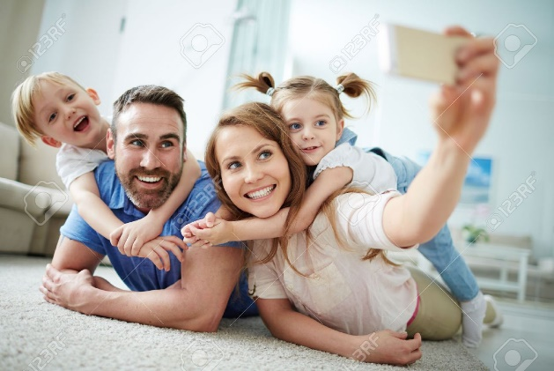

**Describe the Two Pictures**In the first picture, a family of three is posing for a photo, smiling and enjoying a special moment together. They are likely capturing a memory, surrounded by a pleasant setting, such as a park or home. The photograph seems to symbolize happiness, connection, and a shared experience among family members.

In the second picture, a man is sitting at a desk, carefully writing a handwritten letter. He appears focused and thoughtful, possibly expressing his feelings or sharing news with someone. The act of writing a letter shows a personal, intimate way of communication, creating a tangible connection through words.

**The Importance of Reading News**Reading the news is important because it keeps us informed about current events, both locally and globally. Staying up to date helps us understand the world around us, make informed decisions, and participate in society. It can also highlight important social, political, and economic changes that affect our daily lives. News allows us to engage with critical issues, stay connected to our community, and develop a broader perspective on world affairs.

**Do You Like to Preserve Memories by Taking Photos or Writing Them Down?**I enjoy both taking photos and writing memories down, though they serve different purposes. Photos capture moments visually, preserving the details and emotions of an experience. They are a quick and easy way to hold on to memories. Writing, on the other hand, allows for deeper reflection and a more personal connection to the memory. Writing down thoughts or experiences can offer insight into how I felt at the time and allows me to preserve stories in more detail. Both methods are valuable for preserving memories in their own unique ways.

**44. 2 mẹ con mua hàng ở mall + local market**

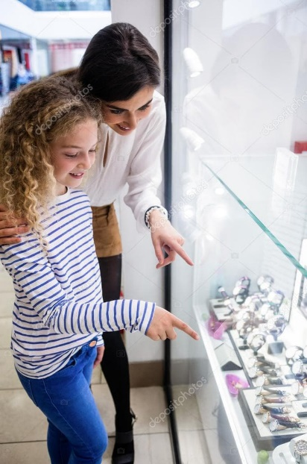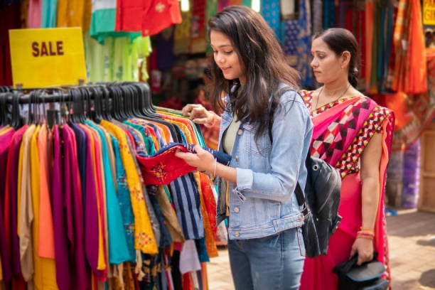

**Describe the Two Pictures**In the first picture, a mother and daughter are shopping at a high-end shopping mall. They are browsing expensive items, likely in a designer store, and their surroundings are modern and elegant, with well-lit displays and a clean, upscale atmosphere. The focus is on luxury and style, with the mother and daughter possibly considering premium purchases.

In the second picture, a mother and daughter are shopping in a colorful local market. They are looking at bright, vibrant clothing and various goods from local vendors. The atmosphere is more lively, with a mix of people and the hustle and bustle of a busy market. The items are more affordable and diverse, with an emphasis on traditional or handmade products.

**Do You Prefer Shopping at Shopping Malls or Local Markets?**I personally prefer shopping at local markets. They offer a more unique and personal experience with a variety of handmade, locally produced goods. The vibrant atmosphere, bargaining, and interaction with local sellers make it more interesting and authentic. Shopping malls, on the other hand, can sometimes feel impersonal and crowded, though they offer convenience and a more comfortable shopping environment.

**Many People Like to Buy Expensive Things. What Is Your Opinion?**I believe that buying expensive things can be a personal choice, but it should be done thoughtfully. While high-end products often offer quality and luxury, I think it's important to consider the value and practicality of purchases. Some people may buy expensive items as a symbol of status or to indulge in themselves, but it's crucial not to overindulge and to prioritize needs over wants. The value of an item doesn’t always correlate with its price—sometimes, something affordable can bring just as much joy.